**D:\skin diseases\Plantar Warts (Verrucas)**

**Plantar Warts (Verrucas)**

Some plantar warts are uncomfortable, particularly if they are on a weight-bearing area when it may feel like having a stone in your shoe.  ‘Mosaic’ warts (see below) are usually painless.

Yes, but no single treatment can be guaranteed to be effective in every case.  The highest cure rates are in young people who have not had their warts for very long.  However, most verrucas will go away by themselves in due course, so it is very reasonable to leave them alone if they are not causing trouble.

Warts are localised thickenings of the skin, and the term ‘plantar warts’ is used for those that occur on the soles of the feet (the ‘plantar’ surface). They are also known as verrucas.

**What causes plantar warts?**

Warts are a form of infection with a virus called the ‘human papilloma virus’. There are many different strains of this virus, and plantar warts are usually due to just a few of these strains.  Infection of the cells of the outermost layer of the skin (the epidermis) with this virus results in this top layer of skin growing and thickening, creating the non-cancerous skin growth that is a wart.

Plantar warts are caught by contact with virally-infected skin scales: these are usually encountered on such surfaces as the floors of public locker rooms, shower cubicles and the tiled areas around swimming pools. However, the virus is not highly contagious, and it is unclear why some people catch plantar warts while others do not. The virus enters the skin through tiny breaks in the skin surface, and moistness and maceration of the skin on the feet probably make infection with the wart virus easier.

**Are plantar warts hereditary?**

No.

**What are the symptoms of plantar warts?**

Some plantar warts are uncomfortable, particularly if they are on a weight-bearing area when it may feel like having a stone in your shoe.  ‘Mosaic’ warts (see below) are usually painless.

What do plantar warts look like?

Plantar warts can occur anywhere on the soles and toes, and they often involve the weight-bearing areas. They vary in size from just a few millimetres to more than one centimetre. Each has a rough surface that protrudes slightly from the skin surface, surrounded by a horny collar. Close inspection of a plantar wart may reveal small black dots (which are blocked blood vessels).  An individual may have one or many verrucas, sometimes associated with warts elsewhere on the body. The term ‘mosaic wart’ is used when many small plantar warts pack together into a small area (resembling mosaic tiling).

**How will plantar warts be diagnosed?**

Usually this is easy, and based simply on the appearance. However, sometimes it may be hard to tell a plantar wart from a corn. One helpful point is that plantar warts interrupt the fine skin ridges on the sole, whereas corns do not. Your doctor may need to pare down the area to be certain of the diagnosis: he/she will be looking for the small black dots which confirm the diagnosis of a viral wart.  No other investigations are needed.

**Can plantar warts be cured?**

Yes, but no single treatment can be guaranteed to be effective in every case.  The highest cure rates are in young people who have not had their warts for very long.  However, most verrucas will go away by themselves in due course, so it is very reasonable to leave them alone if they are not causing trouble.

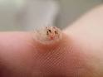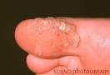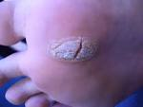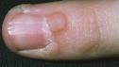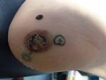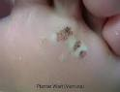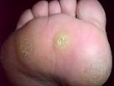C:\Users\Eheena Gaur\Desktop\skin diseases\New folder\images (8).jpg